4. Microcontroller Experiments using Arduino or MSP430: Control and communication Experiments

a. Mercury tilt switch

b. Laser emitter

1. Mercury tilt switch

Components Required

* [Arduino](https://electrosome.com/arduino/) Uno
* Tilt Sensor
* LED
* 220Ω Resistor
* Buzzer
* Bread Board
* Jumper Wires

Mercury Tilt Sensor

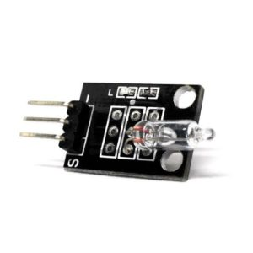

Tilt Sensor

Specifications

* Tilt sensor consists of 3 pins : GND, VCC, DO (Output Signal)
* Operating Voltage : 3.3 V to 5 V
* Maximum output current : 15mA

Working

Not Tilted

When the sensor is in “Not Tilted” position, the mercury ball will be at the bottom and shorting the contacts as shown in the image below. This will turn ON the LED and the output will be LOW.

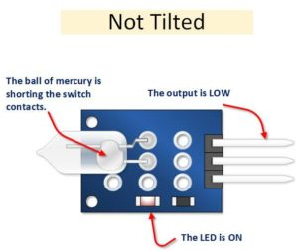

Tilted

When the sensor is in “Tilted” position, the mercury ball will move away from the contacts as shown in the image below. This will turn OFF the LED and the output will be HIGH.

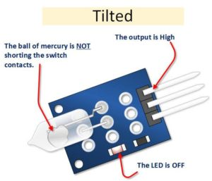

Circuit Diagram

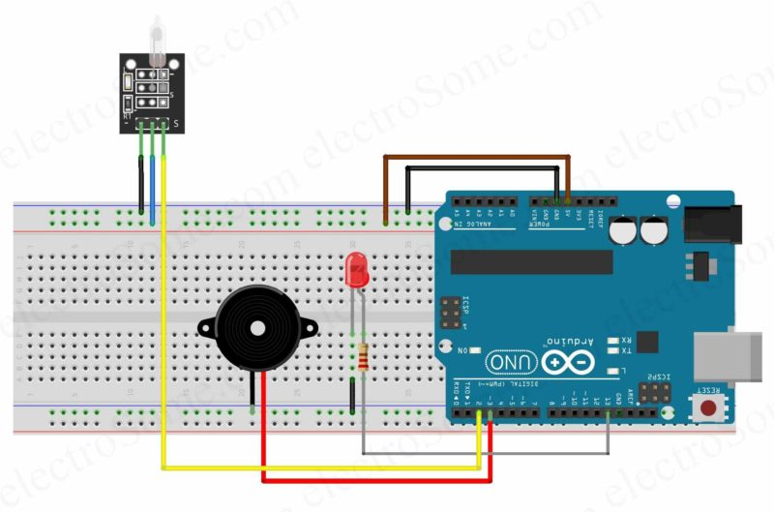

Description

* The GND pin of tilt sensor – GND pin of Arduino Uno.
* The VCC pin of tilt sensor – 5V pin of Arduino Uno.
* The output pin of tilt sensor – pin 2 of Arduino Uno.
* The positive pin of the buzzer – pin 3 of Arduino Uno
* The negative pin of the buzzer – the GND.
* The positive pin of the LED – pin 13 of Arduino Uno
* The negative pin of the LED – GND

Program

void setup() {

pinMode(13, OUTPUT);

pinMode(3, OUTPUT);

pinMode(2, INPUT);

}

void loop() {

if (digitalRead(2) == 1)

{

digitalWrite(13, HIGH);

digitalWrite(3, HIGH);

delay(300);

digitalWrite(13, LOW);

digitalWrite(3, LOW);

delay(300);

}

}

1. Laser emitter

The [KY-008](https://www.hackster.io/infoelectorials/review-001-ky-008-laser-module-review-c20246) is a laser transmitter module that creates a dot-shaped laser beam that can be used as a laser pointer or to create mini laser shows. It is compatible with [Arduino](https://www.build-electronic-circuits.com/what-is-arduino/), Raspberry PI, ESP32, and other popular microcontrollers.

Specifications

Wavelength: 650 nm (Red)  
​​Laser Power: 5 mW  
  
Operating Voltage: 3-5 volts  
​Operating Current: ~ 30 mA

KY-008 Pinout

The KY-008 Ardunio laser module board has three pins.

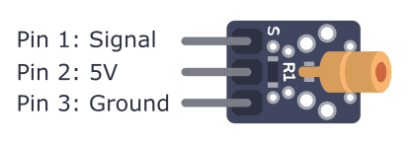

Starting from the pin marked with S, the pins of the laser module are:

* **Pin 1:** Signal pin (to activate and deactivate laser)
* **Pin 2:** 5 V
* **Pin 3:** Ground

First, connect the 5V and Ground pins to 5V and GND on your Arduino. Then connect the Signal pin to any of the digital output pins on your Arduino. By setting the Signal pin high or low, you can turn the laser on and off.

Components required:

Bottom of Form

* Arduino
* Laser Module
* Jumper Wires

Wiring Diagram

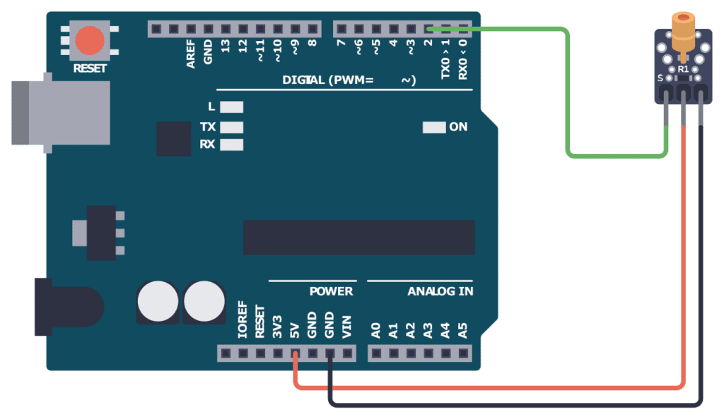

Connect pin 1 (S) of the laser module to pin 2 of the Arduino. Connect pin 2 (VCC) to the 5V pin of the Arduino. Then connect pin 3 (GND) to one of the GND pins of the Arduino.

Program

// Code for blinking a laser module using Arduino

// Author: Oyvind N. Dahl

// Website: https://www.build-electronic-circuits.com/

void setup() {

pinMode(2, OUTPUT);

}

void loop() {

digitalWrite(2, HIGH);

delay(300);

digitalWrite(2, LOW);

delay(700);

}